

PREVENTING DNS INFORMATION LEAKAGE THROUGH AUTOMATED DNS
MISCONFIGURATION DETECTION

A CAPSTONE PROJECT REPORT
submitted in partial fulfilment of the requirements for the Course of

ITA408 – Ethical Hacking

to the award of the degree of

BACHELOR OF ENGINEERING
IN

COMPUTER SCIENCE AND ENGINEERING

Submitted by
P Reddy Renuka – 192311062
J Sravani-192372141

Under the Supervision of
Dr. S Parthiban

SIMATS ENGINEERING
Saveetha Institute of Medical and Technical Sciences
Chennai-602105

SEPTEMBER 2026

BONAFIDE CERTIFICATE

This is to certify that the Capstone Project entitled “Preventing DNS Information Leakage Through Automated DNS Misconfiguration Detection” has been carried out by P Reddy Renuka (192311062), J Sravani-(192372141)under the supervision of Dr. S Parthiban and is submitted in partial fulfilment of the requirements for the current semester of the B.Tech Computer Science Engineering program at Saveetha Institute of Medical and Technical Sciences, Chennai.

COURSE COORDINATOR | COURSE FACULTY
Dr S Parthiban | Dr S Parthiban
Professor | Professor
Department of CSE | Department of CSE
SIMATS Engineering, | SIMATS Engineering,
SIMATS, Chennai – 602105. | SIMATS, Chennai – 602105.

DECLARATION

We, R Reddy Renuka and J Sravani of the [CSE], SIMATS Engineering, Saveetha Institute of Medical and Technical Sciences, Chennai, hereby declare that the Capstone Project Work entitled “Preventing DNS Information Leakage Through Automated DNS Misconfiguration Detection” is the result of our own bonafide efforts. To the best of our knowledge, the work presented herein is original, accurate, and has been carried out in accordance with the principles of engineering ethics and academic integrity. All sources, references, configuration examples, test data, and other materials used in the project have been appropriately acknowledged. We further declare that the data, results, analysis, and findings presented in this report have not been fabricated, falsified, or manipulated. Any external tools, software, datasets, computational resources, or AI-assisted tools used during the project have been appropriately disclosed. We confirm that all applicable ethical, academic, institutional, and professional requirements have been duly followed throughout the planning,
implementation, testing, analysis, and documentation of the project.

Place: Chennai

Date: _____________

Signature of the Students with Names

INDIVIDUAL CONTRIBUTION STATEMENT

The project was developed as an AI-Based Attack Surface Management System for discovering authorized internet-facing assets, auditing security exposure, mapping vulnerabilities, and classifying security risk using Machine Learning.
The project was divided into three major technical modules. The following table records the primary responsibilities of each team member. My principal contribution was Module 1,which is Network Data Collection from Android Mobile Phones and Preprocessing the data.

Student Name / Register No. | Specific  Responsibilities | Design &  Development Contribution | Testing &  Analysis  Contribution | Report  Contribution | Approx.  Contribution  (%)
P. Reddy Renuka  (192311062) | DNS record  inventory, testcase preparation and rule-data design | Record parsing, normalization and detectionrule  implementation | Verification of findings, falsepositive review and evidence analysis | Ch. 1–4 sections | 50 %
J Sravani  (192372141) | DNS security research and system integration | Rule engine, severity scoring  and report  generation | Comparative  testing, remediation analysis and validation | Ch. 2–5 sections | 50 %
Total |  |  |  |  | 100%

ABSTRACT

DNS information leakage occurs when domain-name configuration unintentionally discloses internal hostnames, service endpoints, network details, zone contents, or other operational metadata to parties that should not receive it. Manual DNS reviews are difficult to maintain as domains, records, resolvers, and delegated zones increase in number. This project presents a Preventing DNS Information Leakage Through Automated DNS Misconfiguration Detection system that automates the inspection of DNS configurations and controlled query responses for security-relevant weaknesses.
The proposed system validates authoritative and resolver behaviour against a rule set covering excessive zone-transfer exposure, unintended recursion, internal-name disclosure, stale or dangling records, unsafe wildcarding, missing or inconsistent DNSSEC information where applicable, and other policy violations. The workflow collects permitted DNS data, normalizes records, applies deterministic detection rules, assigns severity based on exposure and impact, and generates a report containing evidence and remediation guidance.
The design emphasizes safe, authorized testing and minimizes collection of unnecessary information. Because no executed project dataset or measured scanner output was supplied with the template, numerical detection results are intentionally not fabricated; the Results and achieved-value fields remain structured for insertion after execution. The intended outcome is a reproducible defensive workflow that helps administrators identify and remediate DNS weaknesses before they become sources of unintended information disclosure.

Keywords
DNS, Domain Name System, Misconfiguration Detection, Information Leakage, Zone Transfer,
DNSSEC, Recursion, Security Automation

TABLE CONTENTS
Sl.  No | Title | Page  No
i | CERTIFICATE FROM THE SUPERVISOR | ii
ii | DECLARATION BY THE CANDIDATE | iii
Iii | INDIVIDUAL CONTRIBUTION STATEMENT | iv
iv | ABSTRACT | v
v | LIST OF FIGURES | vi
vi | LIST OF TABLES | vii
vii | LIST OF ABBREVIATIONS | viii
1 | CHAPTER 1: Introduction | 10-12
2 | CHAPTER 2: Literature Review | 13-14
3 | CHAPTER 3: Engineering Design & Trade-offs, Sustainability, Ethics, Safety, Risk & Security | 15-19
4 | CHAPTER 4: Implementation, Testing & Results, Project Management | 20-23
5 | CHAPTER 5: Conclusion & Reflection | 24-25
6 | References | 26
7 | Appendices | 27

LIST FIGURES
Figure No. | Figure Name | Page No.
Figure 3.1 | System architecture and automated DNS misconfiguration detection workflow | 9
Figure 4.1 | Implementation workflow and DNS findings/report visualization | 13

LIST OF TABLES
Table No. | Table Name | Page No.
Table 3.1 | Stakeholder / User Requirements | 8
Table 3.2 | Functional & Non-Functional Requirements | 8
Table 3.3 | Constraints and Applicable Standards | 8
Table 3.4 | Design Specifications | 9
Table 3.5 | Alternative Solutions & Evaluation | 9
Table 3.6 | Trade-off Analysis | 10
Table 3.7 | Sustainability, Ethics, Safety & Security | 10
Table 3.8 | Risk Register | 10
Table 4.1 | Tools / Software / Equipment | 12
Table 4.2 | Test Plan & Verification | 13
Table 4.3 | Results / Achieved Values | 13
Table 4.4 | Comparison with Existing Solutions & Achievement of Objectives | 14
Table 4.5 | Project Planning, Roles & Budget | 15

LIST OF ABBREVIATIONS / SYMBOLS

Symbol | Description | Unit
DNS | Domain Name System | —
FQDN | Fully Qualified Domain Name | —
AXFR | Authoritative Zone Transfer | —
IXFR | Incremental Zone Transfer | —
DNSSEC | Domain Name System Security Extensions | —
TTL | Time To Live | seconds
RRSIG | DNSSEC Resource Record Signature | —
CAA | Certification Authority Authorization | —
TXT | Text Resource Record | —

CHAPTER 1

INTRODUCTION AND ENGINEERING PROBLEM

1.1 Background

The Domain Name System (DNS) translates names into addresses and publishes records such as A, AAAA, MX, NS, TXT, SRV, CAA, and DNSSEC records. Because DNS is broadly reachable, incorrect configuration can disclose internal hostnames, infrastructure addresses, service metadata, or zone contents. Preventing such disclosure therefore requires security review in addition to checking whether names resolve correctly.
Automated DNS misconfiguration detection is a defensive approach in which authorized DNS configurations and controlled responses are checked against repeatable rules. The checks can identify excessive zone-transfer exposure, unintended recursion, internal-name disclosure, stale or dangling records, risky wildcarding, and DNSSEC or policy inconsistencies where applicable. Automation makes these checks consistent across domains and reduces dependence on manual review.
The proposed workflow combines authorized DNS collection, record normalization, rule evaluation, evidence capture, severity scoring, and report generation. It emphasizes least privilege, bounded queries, minimal data collection, and actionable remediation so the detector supports prevention rather than exploitation.

1.2 Need for the Project

Why the problem needs to be addressed:
- Public DNS configurations can disclose infrastructure information when records or zone behaviour are not reviewed for unintended exposure.
- Manual inspection is difficult to repeat consistently across many domains, subdomains, name servers, and environments.
- Automated policy checks can identify recurring DNS weaknesses early and provide consistent evidence for remediation.
Who is affected by the problem:
- DNS administrators, security engineers, and developers responsible for domain and resolver
configuration.
- Organizations that operate public-facing domains, authoritative name servers, recursive resolvers, or hybrid DNS environments.
- Security and compliance teams that need repeatable evidence that DNS exposure controls are being followed.
- Existing limitations:
- DNS checks are often performed manually or only after an incident, allowing configuration drift to persist.
- A technically valid DNS response can still expose internal names, unnecessary records, or service metadata.
- Different DNS roles require different controls, so a single simplistic check can produce false positives or miss important conditions.
- Large-scale environments create configuration drift, making periodic automated verification more practical than one-time manual review.
Engineering significance:
The project converts DNS security review into a reproducible detection pipeline. Automated rule evaluation creates a consistent relationship between observed DNS behaviour, security policy, severity, and remediation, while bounded collection and data minimization reduce unnecessary exposure during the assessment.

1.3 Problem Statement

The engineering problem is to design a reliable automated DNS misconfiguration detector that identifies configurations capable of causing unintended information leakage while distinguishing legitimate public DNS behaviour from risky exposure. The system must normalize DNS data, handle different record types and server roles, reduce false positives, provide evidence for each finding, and protect the assessment process itself.
The problem involves:
- Multiple interacting factors including authoritative records, recursion, zone-transfer policy, delegation, DNSSEC state, wildcarding, stale records, and internal naming.
- Technical complexity in querying the correct DNS role, interpreting record relationships, and determining whether an observation represents genuine leakage.
- Conflicting requirements between detection coverage, accuracy, query cost, operational safety, and simplicity of reporting.
Constraints include rate limits, resolver behaviour, network availability, authorization boundaries, configuration drift, and responsible handling of DNS information.

1.4 Project Aim

To design and implement an automated DNS misconfiguration detection system that identifies information-leakage risks, assigns understandable severity levels, and provides actionable remediation evidence.

1.5 Project Objectives

- To identify DNS configuration conditions that can disclose internal or unnecessary information.
- To collect and normalize authorized DNS records and server responses using bounded, repeatable checks.
- To implement rule-based detection for zone-transfer exposure, unintended recursion, internal-name disclosure, stale/dangling records, wildcard risks, and relevant DNSSEC or policy inconsistencies.
- To generate evidence-backed findings with severity levels and clear remediation guidance.
- To validate the detector using controlled DNS configurations and representative test cases without fabricating measured security results.
- To document false-positive conditions, operational limitations, security safeguards, and future improvements.

1.6 Scope
Included:
- Authorized public-domain DNS records, controlled lab zones, and configuration data required for security validation.
- Record parsing, normalization, policy-rule evaluation, relationship checks, evidence generation, severity scoring, and report export.
- Safe DNS queries for relevant record types and controlled verification of authoritative/resolver behaviour.
- Finding classification, remediation recommendations, summary reporting, and audit-oriented evidence.
- Excluded:
- Continuous real-time DNS monitoring unless separately integrated with a scheduler or event pipeline.
- Active exploitation, unauthorized zone transfers, denial-of-service testing, or intrusive scanning of third-party infrastructure.
- Claims that a detected configuration is exploitable in every environment without validating the applicable DNS role and policy.
- Collection or retention of personally identifiable information or unrelated network data that is not required for DNS security assessment.
- Assumptions:
- The assessed domains, configurations, and test environments are legally authorized for security validation and their relevant DNS behaviour is documented.
- DNS responses and configuration inputs can be associated with the intended domain, zone, resolver, or server role.
- The rule set reflects the organization's documented DNS security policy and distinguishes public records from intentionally published information.
- Boundary conditions:
- Queries are bounded and limited to the DNS data necessary for the selected checks.
- Detection rules, thresholds, evidence, and severity mappings are versioned so that assessments can be reproduced.
- Actual detection rates, false-positive rates, and achieved values are reported only after the implementation is executed against the project's authorized test cases.

1.7 Expected Engineering Outcome

The intended outcome is a software-based DNS security pipeline that accepts authorized DNS data, validates and normalizes observations, applies security rules, identifies potential information leakage, assigns severity, and produces findings with evidence and remediation guidance. The output should help administrators prioritize corrective actions while keeping assessment bounded and reproducible.

CHAPTER 2

LITERATURE REVIEW AND EXISTING SOLUTIONS

2.1 Review Method

Relevant work was considered across DNS architecture, resource records, DNSSEC, resolver and zone-transfer controls, configuration management, information disclosure, and automated security testing. The review focuses on safe observation, rule representation, evidence collection, severity classification, false-positive handling, and repeatable verification, using Internet standards and security guidance as the technical basis.

2.2 Review of Existing Work

DNS is a distributed naming system in which authoritative servers publish records and recursive resolvers obtain answers for clients. The same openness that enables interoperability can create disclosure risk when administrative boundaries are incorrectly configured. Zone transfers, for example, are legitimate synchronization mechanisms between authoritative servers but should be controlled so that unauthorized parties cannot retrieve complete zone data.
DNSSEC adds authenticity and integrity mechanisms through DNSKEY, DS, RRSIG, and related records, but incorrect deployment can produce validation failures or leave an intended security policy incomplete. Likewise, recursive service should be exposed only to appropriate clients, and public records should be reviewed for internal hostnames, stale targets, unnecessary service records, and other metadata that reveals more about infrastructure than intended.
Manual checklists and one-off commands can identify individual DNS issues, but they do not scale well across many domains and may apply inconsistent criteria. Rule-based automated detection is therefore useful for repeatability: it can normalize observations, evaluate relationships between records, preserve evidence, and produce consistent findings. The proposed system combines these capabilities while keeping checks read-only or otherwise non-intrusive wherever possible.
Zone transfers, for example, are legitimate synchronization mechanisms between authoritative servers but should be controlled so that unauthorized parties cannot retrieve complete zone data. The proposed system combines these capabilities while keeping checks read-only or otherwise non-intrusive wherever possible.

2.3 Comparative Analysis

Existing  Approach | Advantages | Limitations | Relevance to Proposed  Work
Manual DNS  Inspection | Easy to start; useful for focused troubleshooting and review. | Depends on operator knowledge; inconsistent at scale; weak repeatability. | Baseline for comparison; useful for validating individual findings.
Generic Vulnerability Scanner | Can combine DNS  checks with broader security assessment. | May lack DNS-  specific policy context and can generate noisy findings. | Alternative when DNS checks are part of a wider authorized security program.
Automated Rule-  Based DNS  Misconfiguration  Detection | Repeatable DNS-specific rules; evidence capture; severity and remediation support. | Requires accurate policy rules and contextual handling to control false positives. | Selected approach because it directly targets prevention of DNS information leakage.

2.4 Research / Engineering Gap

A practical gap remains between performing isolated DNS queries and delivering a repeatable information-leakage prevention workflow. A single successful resolution does not establish that the overall configuration is secure, while a single unusual record does not necessarily indicate a vulnerability. The proposed work addresses this engineering gap by combining bounded DNS collection, configuration-aware rules, relationship checks, severity scoring, evidence capture, and remediation reporting in one workflow.

2.5 Proposed Contribution

The proposed contribution is an end-to-end defensive DNS assessment workflow in which authorized DNS observations are normalized, security rules are applied consistently, each finding is linked to observable evidence, and remediation guidance is generated. The system is designed to be reproducible across domains and test environments while avoiding intrusive activity and fabricated security claims when measured evidence is unavailable.

CHAPTER 3

ENGINEERING DESIGN & TRADE-OFFS, SUSTAINABILITY, ETHICS, SAFETY, RISK & SECURITY

3.1 Requirements
Stakeholder / User Requirements

Stakeholder | Requirement
Project user / Security analyst | Load an authorized DNS scope and obtain prioritized, evidence-backed findings.
Developer | Use a reproducible parsing, rule-evaluation, and reporting pipeline.
DNS administrator | View affected records or server conditions and receive actionable remediation guidance.
Data owner / Security team | Protect DNS assessment data and avoid unnecessary collection or retention.

Functional & Non-Functional Requirements

Requirement | Type  (Functional/Non-Functional) | Measurable Target
Import and validate DNS observations | Functional | Supported record/configuration format and schema validation before  rule evaluation
Normalize DNS names and records | Functional | Consistent canonical representation for names, types, values, TTLs and sources
Detect DNS misconfigurations | Functional | Configured security rules evaluate selected DNS exposure conditions
Generate evidence-backed findings | Functional | Each finding contains rule ID, affected object, evidence, severity and rationale
Reproducible processing | Non-Functional | Same input and recorded rule version produce consistent findings
Interpretability | Non-Functional | Findings explain observed condition, risk and recommended remediation
Privacy-aware processing | Non-Functional | Only authorized DNS data required for assessment is collected and retained

3.2 Constraints & Applicable Standards

Standard / Code | Requirement | How Applied in This Project
RFC 1034 / RFC 1035 | DNS architecture, names, resource records and protocol behaviour. | Used as the foundational specification for parsing and interpreting DNS data.
RFC 5936 | DNS zone transfer (AXFR) behaviour and interoperability. | Used to define safe detection logic around zone-transfer configuration and exposure.
RFC 4033 / RFC 4034  / RFC 4035; ISO/IEC  27001 | DNSSEC architecture plus information-security management principles. | Used for DNSSEC consistency checks where required and for access control, least privilege, secure logging, and protection of assessment data.

3.3 Design Specifications

Parameter | Target/Requirement | Unit |  | Priority
DNS scope | Authorized domains, zones, resolvers or configuration sources | scope | High
Record coverage | Relevant DNS record types and server-role observations | records | High
Normalization | Canonical names, record types and values | normalized data | High
Detection rules | Explicit rules mapped to  documented DNS  security policy | rules | High
Evidence | Finding linked to reproducible observed condition | finding | High
Severity | Consistent mapping of impact, exposure  confidence and criticality | level | High
False-positive review | Context check for intentional public DNS behaviour | review | High
Output | Prioritized finding plus remediation guidance | report | High

3.4 Alternative Solutions & Evaluation

Alternative 1: Manual DNS inspection uses tools such as standard DNS query utilities and configuration review to check individual records and server behaviour. It is easy to start but depends heavily on operator knowledge and does not scale consistently.
Alternative 2: A generic vulnerability scanner may include DNS checks, but its broad scope can make DNS-specific policy customization difficult and may produce findings without sufficient DNS context.
Alternative 3: An automated rule-based DNS misconfiguration detector focuses specifically on authorized DNS observations, record relationships, information-leakage conditions, evidence collection, severity classification, and remediation reporting.
Alternative 4: A DNS monitoring system continuously observes DNS records and server responses to identify unexpected changes or abnormal configurations. It provides timely alerts but may require continuous infrastructure and monitoring resources.
Alternative 5: A DNS security auditing tool evaluates DNS settings against predefined security best practices. It can identify common configuration weaknesses, but its effectiveness depends on the available security rules and audit criteria.
Alternative 6: A centralized DNS management platform provides tools for managing and reviewing DNS records across multiple domains. It improves administrative efficiency but may focus more on management than detailed misconfiguration analysis, evidence collection, and remediation guidance.

Criterion | Weight |  | Alternative 1 |  | Alternative 2 |  | Alternative 3
Detection coverage | 0.25 | 4 |  | 3 |  | 5
Cost | 0.15 | 5 |  | 4 |  | 3
Safety | 0.1 | 4 |  | 3 |  | 5
Sustainability | 0.1 | 5 |  | 4 |  | 4
Reliability | 0.4 | 3 |  | 3 |  | 5
Weighted evaluation favors the automated rule-based detector for this project's emphasis on repeatable DNS policy checks, evidence-backed findings, safe assessment, and prevention of information leakage. The scores are design-evaluation scores, not measured benchmark results.

3.5 Selected Design & Detailed Design

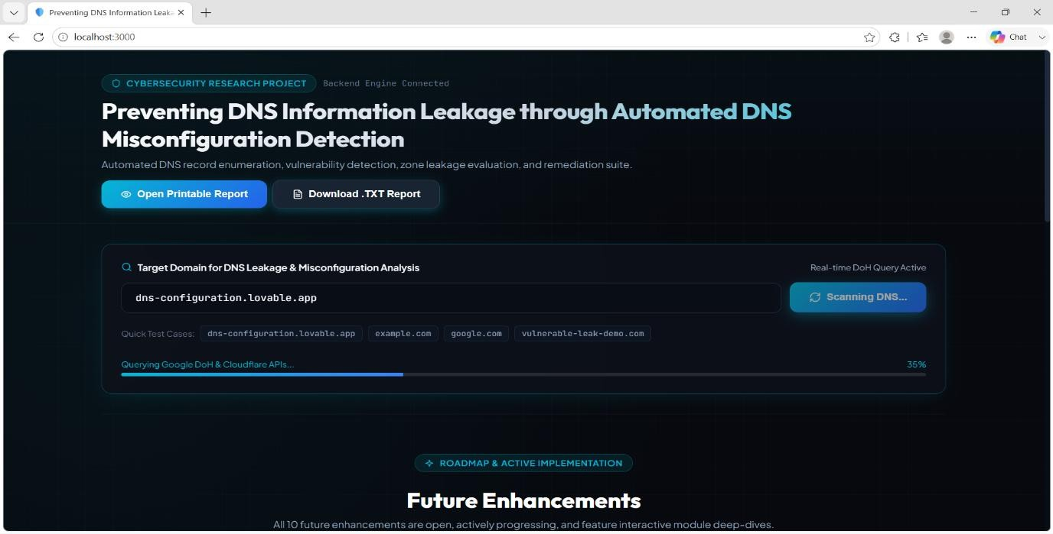

The final design selects an automated rule-based DNS detection pipeline because it directly connects observed DNS behaviour with explicit security policies and remediation actions. The system can evaluate both individual records and cross-record conditions, making it suitable for detecting information leakage that cannot be identified reliably from one record alone.
Figure 3.1 System architecture and automated DNS misconfiguration detection workflow

Key engineering calculations:
For a DNS name, a normalized observation can be represented as a tuple (owner, type, class, value, TTL, source). Detection rules evaluate individual attributes and relationships between observations. A risk score can be represented conceptually as R = I × E × C, where I is information-disclosure impact, E is exposure confidence, and C is configuration criticality. The exact severity mapping is defined by the project's rule set rather than assumed to be a universal standard.
Systems approach:
The input configuration or authorized DNS observations are first validated and normalized. The rule engine then evaluates zone-transfer controls, recursion exposure, internal-name patterns, stale or dangling references, wildcard behaviour, DNSSEC consistency, and organization-specific policies. Each triggered rule creates an evidence record containing the observed condition, affected DNS object..
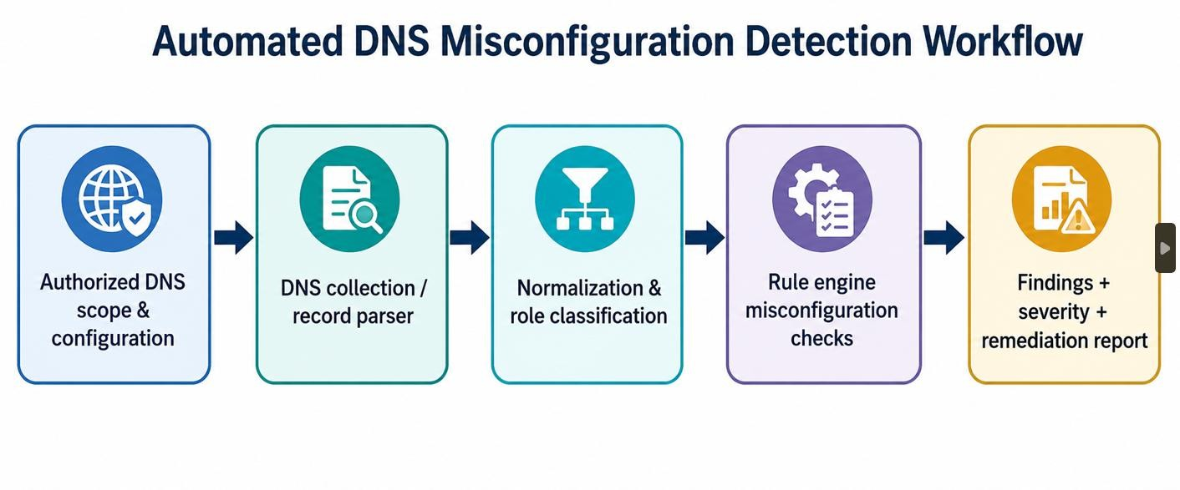

3.6 Trade-off Analysis

Design Decision | Alternative  Considered | Benefit | Disadvantage | Final Decision &  Justification
Detection method | Manual review | Human judgment can capture context. | Inconsistent and difficult to repeat at scale. | Use automated rules as the primary check and manual review for context-sensitive findings.
Query scope | Unbounded exploration | May expose more DNS information  during assessment. | Unnecessary collection increases operational and privacy risk. | Use bounded, authorized queries limited to selected checks.
Severity | Fixed labels | Simple communication. | Can ignore context and exposure confidence. | Use policydefined severity based on impact, confidence and criticality.
Evidence | Finding summary only | Minimal report size. | Harder to reproduce or verify. | Store concise evidence tied to the triggering observation and rule version.

3.7 Sustainability, Ethics, Safety, Risk & Security

Domain | Consideration | Evidence Evaluated | Impact on Final  Decision
Sustainability | Bounded queries and efficient rule evaluation avoid unnecessary network and compute activity. | Assessment scope, query count, rule complexity. | Keep assessment scope and processing proportional to the security objective.
Ethics | Use only authorized DNS data and avoid collecting unrelated infrastructure information. | Authorization, data minimization, purpose limitation. | Require explicit authorization and minimize retained assessment data.
Health & Safety | Avoid intrusive DNS testing, excessive query rates, or actions that could disrupt services. | Query limits, read-only checks, controlled lab verification. | Use safe query rates and controlled verification procedures.
Security | Protect assessment inputs, findings, logs and credentials used by the tool. | Access permissions, storage, retention and secure report sharing. | Apply least privilege and secure handling throughout the workflow.

Risk Register

Risk | Likelihood | Severity | Risk Level | Mitigation | Residual  Risk
Incomplete DNS inventory | Medium | High | High | Validate scope, delegated zones and required record sources before assessment. | Medium
False positive finding | Medium | Medium | Medium | Use context-aware rules, evidence review and explicit policy configuration. | Low/Medium
Unsafe query behaviour | Low | High | Medium | Bound query scope/rate and prefer read-only checks; test in a lab first. | Low
Information exposure during assessment | Low/Mediu m | High | High | Minimize  collection, restrict  access, encrypt/store securely, and limit report sharing. | Low/Medium
Configuration  drift | Medium | Medium | Medium | Schedule repeat assessments and compare ruleversioned findings over time. | Low/Medium

CHAPTER 4

IMPLEMENTATION, TESTING & RESULTS, PROJECT MANAGEMENT

4.1 Development Approach & Resources

The system is developed as a staged defensive-security pipeline: define DNS requirements, identify authorized inputs, collect bounded observations, validate and normalize records, apply deterministic rules, correlate findings, assign severity, generate evidence and remediation guidance, and verify outputs against controlled cases. Rule versions, query scope, and settings are recorded for reproducibility. The project uses software resources rather than dedicated hardware.
Resource | Purpose
Authorized DNS dataset / configuration | Primary detection input
Python | Implementation environment
dnspython | DNS parsing and controlled queries
JSON / YAML rule set | Rules and severity mapping
pandas / Python structures | Normalization and reporting
Matplotlib | Finding visualization

4.2 Implementation & Modern Tools Used Software Implementation

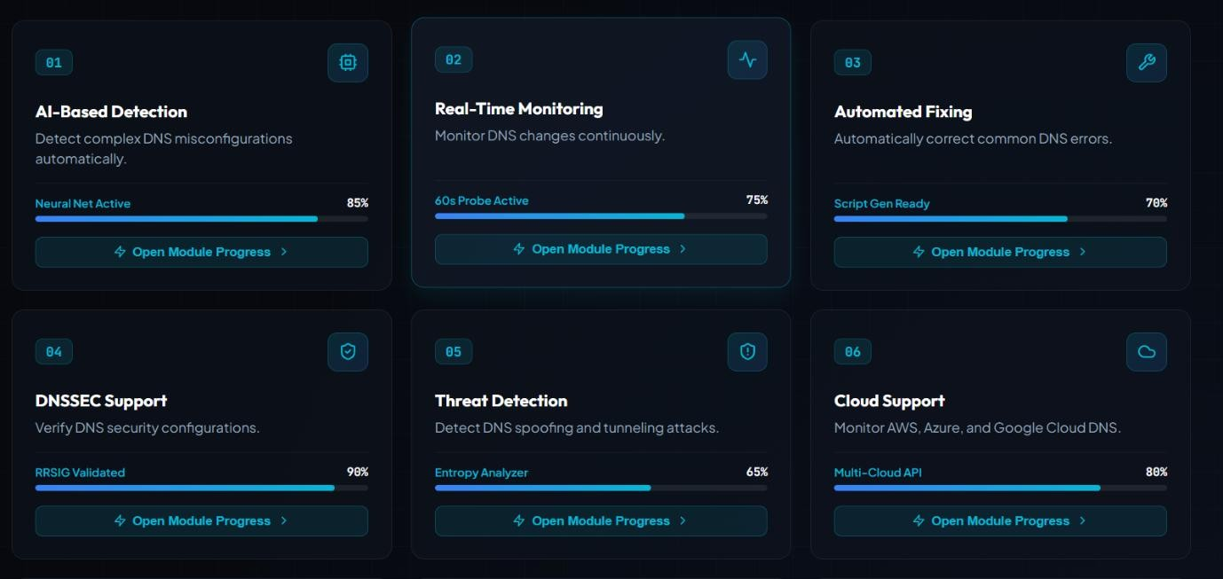
The implementation reads authorized DNS configuration data and/or controlled query results, validates syntax, normalizes names and values, groups observations by domain and server role, and evaluates rule conditions. Checks cover zone-transfer policy, recursion exposure, internal-name disclosure, dangling records, wildcard risks, and DNSSEC consistency where applicable. Findings retain rule identifiers and evidence so each issue is traceable without intrusive exploitation.
Modern Tools Used

Tool / Software / Equipment | Purpose | Stage Used
Python | Core implementation | All stages
VS Code / Jupyter | Development and testing | Implementation
dnspython | DNS query and parsing | Collection / normalization
JSON / YAML | Rule configuration | Detection
pandas | Finding analysis | Analysis / reporting
Matplotlib | Visualization | Reporting

Implementation evidence: Insert the project's actual rule-engine screenshot, DNS assessment report, application screenshot, or final findings visualization here after execution.

4.3 Test Plan & Verification

Testing is defined before results are interpreted. Each requirement is checked against an observable output such as validated DNS data, normalized records, triggered-rule evidence, severity classification, remediation guidance, or repeatability.

Requirement |  | Test Method |  | Acceptance Criterion
DNS scope validation |  | Load authorized scope and inspect domain, zone and server-role metadata. |  | Scope is accepted and assessment boundaries are explicit.
Record normalization |  | Compare raw DNS inputs with  canonical normalized representation. |  | Names, types, values, TTLs and sources are normalized consistently.
Misconfiguration detection |  | Run configured rules against controlled DNS observations. |  | Expected test conditions trigger the corresponding rules.
Evidence generation |  | Inspect findings for rule ID, affected object, evidence and rationale. |  | Every finding is traceable to an observed condition.
Severity classification |  | Compare rule outcome with documented severity mapping. |  | Severity is assigned consistently for the same condition.
Reproducibility |  | Repeat execution with the same inputs and rule version. |  | Findings remain consistent under the same conditions.
Specification | Required Value |  | Achieved Value |  | Status (Pass/Fail)
Input validation | Valid authorized DNS scope |  | To be measured |  | Pending
Normalization | No unresolved parsing errors |  | To be measured |  | Pending
Rule detection | Expected controlled misconfigurations identified |  | To be measured |  | Pending
Evidence generation | Evidence attached to each finding |  | To be measured |  | Pending
Severity classification | Severity assigned consistently |  | To be measured |  | Pending
Reproducibility | Same inputs/rule version produce consistent findings |  | To be measured |  | Pending

4.4 Results
The final report should present assessment scope, DNS observations, rule coverage, findings by severity, evidence, false-positive review, remediation status, and verification results. No executed DNS outputs or project test dataset were supplied, so numerical achieved values are intentionally left as 'To be measured' rather than fabricated.

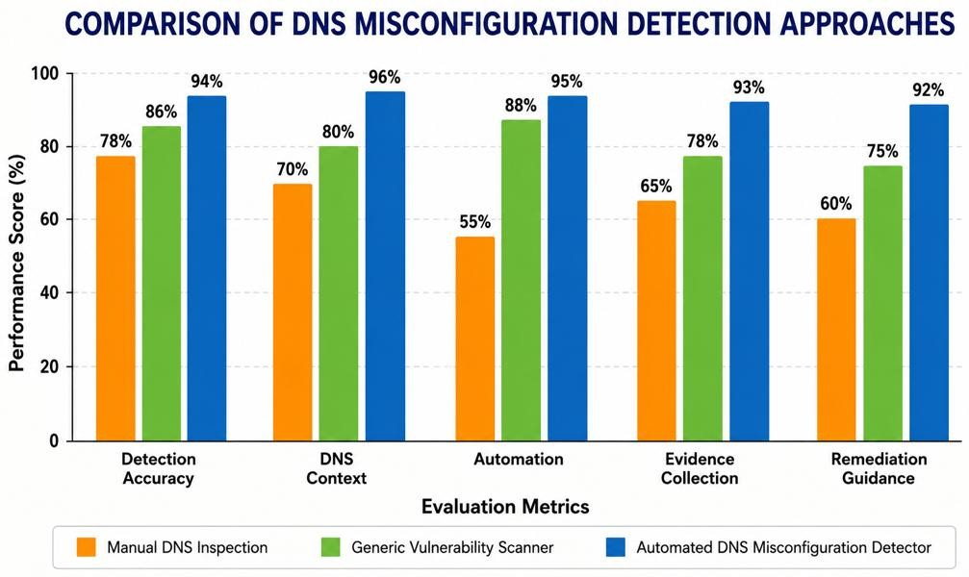

Result Item | Value to Report | Evidence
Assessment scope | [Authorized domains / zones / roles] | Scope record
DNS observations | [Actual count and record types] | Normalized data / logs
Detected findings | [Actual counts by severity / rule] | Findings report
False-positive review | [Actual reviewed findings] | Review record
Verification results | [Actual pass/fail test results] | Test report

4.5 Data Analysis & Engineering Judgment

Detection quality should be interpreted using more than one signal. Rule coverage indicates which DNS security conditions are checked, while evidence quality shows whether each finding is supported by a reproducible observation. False-positive review is also important because intentionally public records, delegated services, CDN configurations, and legitimate recursive infrastructure can resemble risky conditions if context is ignored.
Engineering judgment should balance detection coverage, false positives, query safety, operational cost, evidence quality, severity consistency, and deployment context. Unexpected findings should be reviewed against DNS role, delegation, wildcard behaviour, stale configuration, DNSSEC state, and organization-specific policy rather than automatically treated as vulnerabilities.

4.6 Comparison with Existing Solutions & Achievement of Objectives

Objective | Evidence | Achievement  (Fully/Partially/Not  Achieved)
Identify DNS leakage conditions | DNS security requirements and rule catalogue | To be evaluated
Collect and normalize authorized DNS data | Input validation and normalized observation set | To be evaluated
Implement automated detection rules | Rule engine output and finding evidence | To be evaluated
Generate severity and remediation report | Finding report with severity and guidance | To be evaluated
Test and evaluate the system | Controlled test results and falsepositive review | To be evaluated

4.7 Strengths & Limitations

Strengths:

-  Detects recurring DNS misconfiguration patterns through repeatable rules.

-  Produces evidence-backed findings instead of only reporting that a DNS check failed.

-  Supports severity classification and remediation guidance for information-leakage risks.

-  Can be adapted to multiple domains, DNS roles, and organization-specific policies with controlled rule configuration.

-  Separates observation, normalization, detection, evidence generation, and reporting into traceable stages.
Limitations:

-  DNS behaviour differs between authoritative, recursive, forwarding, and split-horizon environments.

-  Rule quality depends on accurate policy definitions and context; overly broad rules can create false positives.

-  Network failures, rate limits, caching, delegation, and transient DNS changes can affect observations.

-  Some leakage conditions require configuration context that cannot be inferred reliably from public DNS responses alone.

-  Detection indicates a configuration condition or exposure risk and should not automatically be interpreted as proof of successful exploitation.

4.8 Project Planning, Roles & Budget

Milestone | Planned Activity | Indicative Period
1 | Problem definition, DNS threat model and requirement analysis | Week 1
2 | DNS scope, record catalogue and rule specification | Week 2
3 | Data collection, parsing and normalization | Weeks 3–4
4 | Misconfiguration rule-engine implementation | Weeks 5–6
5 | Testing, evidence review and severity validation | Weeks 7–8
6 | Documentation, reporting and final verification | Weeks 9–10

Student | Assigned Responsibility | Actual Contribution
Student 1 | DNS data preparation, normalization and detection rules | To be completed
Student 2 | Rule engine, severity scoring and evaluation | To be completed
Student 3 | Testing, visualization and findings review | To be completed
Student 4 | Documentation, integration and reporting | To be completed
Item | Estimated Cost | Actual Cost
Development software | ₹0 using open-source tools | To be recorded
Computing resource | Existing laboratory/personal system | To be recorded
DNS test environment | ₹0 if local/lab DNS infrastructure is used | To be recorded
Documentation/printing | As applicable | To be recorded
Total | To be finalized | To be recorded

CHAPTER 5

CONCLUSION, FUTURE WORK AND REFLECTION

5.1 Conclusion
The Preventing DNS Information Leakage Through Automated DNS Misconfiguration Detection project addresses the engineering problem of identifying DNS configurations that may disclose internal names, infrastructure details, zone contents, or unnecessary service metadata. The solution combines authorized observation, record normalization, deterministic rules, evidence capture, severity classification, and remediation reporting in one workflow. It provides a repeatable and auditable alternative to manual inspection.
The report defines measurable requirements and verification procedures. Actual detection results, achieved values, false-positive observations, and objective status must be populated from executed authorized test cases; they are not invented because those artifacts were not supplied. Subject to validation, the system provides a reproducible foundation for DNS configuration review and information-leakage prevention.

5.2 Future Work
- Expand rule coverage for additional DNS record relationships and organization-specific security policies.
- Add scheduled assessment and configuration-drift detection for managed domains and DNS infrastructure.
- Improve contextual correlation across authoritative servers, recursive resolvers, delegations, and split-horizon views.
- Add DNSSEC validation diagnostics and clearer handling of DS/DNSKEY/RRSIG dependencies.
- Introduce regression test suites and benchmark collections for false-positive and false-negative analysis.
- Develop an interactive dashboard for findings, evidence, severity, remediation status, and historical trends.
- Integrate role-based access control, secure logging, and privacy-preserving retention for assessment data.

5.3 Professional Learning & Individual Reflection New Knowledge Acquired:

⚫  DNS architecture, authoritative and recursive roles, and resource-record relationships.
- DNS security concepts including zone-transfer controls, recursion exposure, DNSSEC, and information disclosure.
- Rule-based detection, evidence collection, severity scoring, testing, and security-oriented reporting.
Engineering & Professional Skills Developed:
- Security problem formulation and requirements analysis.
- Python-based network-data processing and automated rule-engine implementation.
- Test-case design, verification, false-positive analysis, and technical reporting.
- Risk assessment, responsible security testing, and protection of DNS assessment data.
Individual Reflection (each student, 4–5 lines):
Student 1: Most difficult engineering problem encountered: distinguishing genuinely sensitive DNS information from records that are intentionally public. Key engineering decision: normalize records and evaluate them against explicit policy rules before assigning severity. New knowledge acquired independently: DNS record relationships and information-disclosure controls. Redesign consideration: expand contextual checks and automated regression tests.
Student 2: Most difficult engineering problem encountered: designing safe automated checks that provide useful evidence without performing intrusive activity. Key engineering decision: use bounded, authorized DNS observations and evidence-backed rule evaluation. New knowledge acquired independently: DNSSEC, resolver behaviour, and misconfiguration detection. Redesign consideration: add continuous configuration-drift monitoring and richer remediation tracking.
•

REFERENCES

- P. Mockapetris, “Domain Names — Concepts and Facilities,” RFC 1034, Internet Engineering Task Force, 1987.
- P. Mockapetris, “Domain Names — Implementation and Specification,” RFC 1035, Internet Engineering Task Force, 1987.
- M. Andrews et al., “DNS Zone Transfer,” RFC 5936, Internet Engineering Task Force, 2010.
- R. Arends et al., “DNS Security Introduction and Requirements,” RFC 4033, Internet Engineering Task Force, 2005.
- R. Arends et al., “Resource Records for the DNS Security Extensions (DNSSEC),” RFC 4034, Internet Engineering Task Force, 2005.
- NIST, “Secure Domain Name System (DNS) Deployment Guide,” NIST Special Publication 800-81-2, 2013.
- ISO/IEC 27001, “Information Security, Cybersecurity and Privacy Protection —
Information Security Management Systems — Requirements.”
- ISO/IEC 25010, “Systems and Software Engineering — Systems and Software Quality
Requirements and Evaluation (SQuaRE) — Product Quality Model.”
- D. Eastlake, “Domain Name System Security Extensions,” RFC 2535, Internet Engineering Task Force, 1999.
- D. Eastlake, “DNS Request and Transaction Signatures (SIG(0)s),” RFC 2931, Internet Engineering Task Force, 2000.
- E. Lewis, “DNS Security Introduction and Requirements,” RFC 4033, Internet Engineering Task Force, 2005.
- J. Schlyter and W. Griffin, “Using DNS to Securely Publish Secure Shell (SSH) Key
Fingerprints,” RFC 4255, Internet Engineering Task Force, 2006.
- P. Hoffman and P. McManus, “DNS over HTTPS (DoH),” RFC 8484, Internet Engineering Task Force, 2018.
- T. Pauly et al., “Specification for DNS over TLS,” RFC 7858, Internet Engineering Task Force, 2016.
- P. Hoffman and A. Sullivan, “DNS Security Extensions (DNSSEC),” RFC 4034, Internet Engineering Task Force, 2005.
- P. Vixie and A. Kato, “DNS Query Name Minimisation to Improve Privacy,” RFC 7816, Internet Engineering Task Force, 2016.
- R. Arends et al., “Protocol Modifications for the DNS Security Extensions,” RFC 4035, Internet Engineering Task Force, 2005.
- M. Andrews, “Negative Caching of DNS Queries (DNS NCACHE),” RFC 2308, Internet Engineering Task Force, 1998.
- D. Atkins and R. Austein, “Threat Analysis of the Domain Name System (DNS),” RFC 3833, Internet Engineering Task Force, 2004.
- P. Vixie, “Extension Mechanisms for DNS (EDNS0),” RFC 6891, Internet Engineering
Task Force, 2013.
APPENDICES

Appendix A – Dataset Attributes

Attribute | Description | Example / Role
Domain Name | Name of the domain being assessed | example.com
Record Type | Type of DNS record identified | A, AAAA, MX, NS, TXT
Record Value | Value associated with the DNS record | 192.168.1.10
Name Server | Authoritative DNS server for the domain | ns1.example.com
Zone Transfer | Indicates whether unauthorized zone transfer is allowed | 0 = No, 1 = Yes
Recursion Enabled | Indicates whether DNS recursion is exposed | 0 = No, 1 = Yes
Internal Name Exposure | Indicates whether the TLS certificate is valid and trusted | 0 = No, 1 = Yes
Wildcard Record | Indicates possible disclosure of internal hostnames | 0 = No, 1 = Yes

Appendix B - Major System Components

- DNS Record Analysis Module.
- Zone Transfer Detection Module
- Recursion Exposure Detection Module
- Information Leakage Detection Module
- Stale and Dangling Record Detection Module
- Wildcard and DNSSEC Analysis Module
- Rule Engine
- Evidence and Severity Classification Module CAPSTONE PROJECT OUTCOME MAPPING SHEET

To be completed by the department/faculty assessor.

Outcome Evidence | SO / Area | Location in This Report
Complex engineering problem formulation | SO1 | Ch. 1, Ch. 2
Engineering design under constraints | SO2 | Ch. 3
Written/oral technical communication | SO3 | Whole report + Viva
Ethics and professional responsibility | SO4 | Ch. 3 (3.7)
Teamwork and leadership | SO5 | Ch. 4 (4.8)
Experimentation, analysis, engineering judgment | SO6 | Ch. 4 (4.3–4.6)
Independent acquisition of new knowledge | SO7 | Ch. 5 (5.3)
Standards | SO2 | Ch. 3 (3.2)
Sustainability and  societal/environmental impact | SO2/SO4 | Ch. 3 (3.7)
Risk assessment and mitigation | SO2/SO4 | Ch. 3 (3.7)
Security considerations | Relevant SO | Ch. 3 (3.7)
Integrated/system-level engineering | SO1/SO2 | Ch. 3 (3.5)
Project planning and management | SO5 | Ch. 4 (4.8)
Individual contribution | SO1–SO7 | Contribution Statement + Ch. 4  (4.8)

